**ASSIGNMENT 2**

**DATA STRUCTURES**

**CIRCULAR LINKED LIST**

Name- MAYANK BHATNAGAR

Branch- MECHANICAL

SID-21107034

Section- G1

**Q1.** While traversing a single-circular linked list, which condition establishes that the traversing element/variable has reached the first element?

A Circular linked list is a linked list with its first and last nodes connected to each other to form a circle.

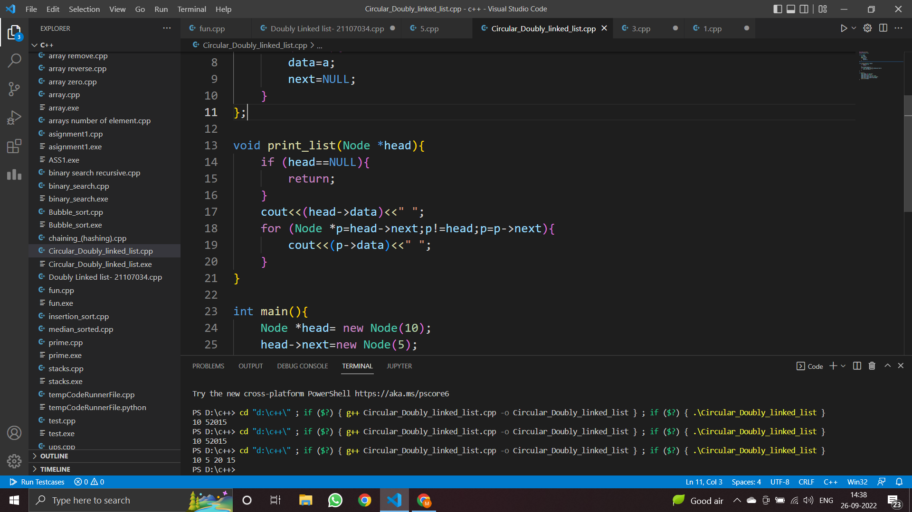

The condition which establishes that the traversing element has reached the first element is in the for condition (line 18): **p!=head**. As soon p==head the loop will stop.

**Q2.** What are the practical applications of a circular linked list? (Try to find applications in your respective fields)

The practical applications of a Circular linked list are:

* Circular lists are used in applications where the entire list is accessed one by one in a loop.
* It is also used by the Operating system to share time for different users, and generally uses a Round-Robin time-sharing mechanism.
* Multiplayer games use a circular list to swap between players in a loop.
* Implementation of Advanced data structures like Fibonacci Heap
* The browser cache which allows you to hit the BACK button
* Undo functionality in Photoshop or Word
* Circular linked lists are used in Round Robin Scheduling
* Circular linked list used Most recent list (MRU LIST)